1. KPI

**Total Revenue:**

select sum(total_price) as Total_Revenue from pizza_sales



**Average_Order_Value**

select SUM(total_price) /COUNT(DISTINCT order_id) as Average_Order_Value from pizza_sales



**Total_Pizzas_Sold**

select sum(quantity) as Total_Pizzas_Sold from pizza_sales



**Total_Order_Placed**

select count(Distinct order_id) as Total_Order_Placed from pizza_sales



**Average_Pizzas_Per_Order**

select Cast(Cast(count(quantity) as Decimal (10,2)) /Cast(count(Distinct order_id) as Decimal (10,2))as decimal (10,2)) as Average_Pizzas_Per_Order from pizza_sales



**Daily_Trends_for_Total_Orders**

select DATENAME(dw,order_date) as Order_Day, count(Distinct order_id) as Total_Orders from pizza_sales

Group By DATENAME(dw,order_date)

Order By Total_Orders Desc

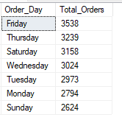

**Monthly_Trends_for_Total_Orders**

select DATENAME(MONTH,order_date) as Month_Name, count(Distinct order_id) as Total_Orders from pizza_sales

Group By DATENAME(MONTH,order_date)

Order By Total_Orders Desc

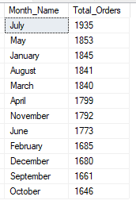

**Percentage of sales by Pizza Category**

select pizza_category, sum(total_price) as total_Sales, sum(total_price)*100/(select sum(total_price)as Total_Orders from pizza_sales) as Total_Orders from pizza_sales

group by pizza_category

Order by Total_Orders Desc

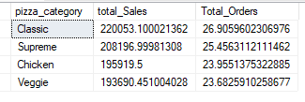

**Percentage of sales by Pizza Size**

select pizza_size, sum(total_price) as total_Sales, sum(total_price)*100/(select sum(total_price)as Total_Orders from pizza_sales) as Total_Orders from pizza_sales

group by pizza_size

Order by Total_Orders Desc

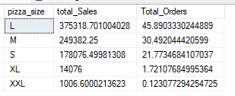

**Total Pizzas Sold by Pizza Category**

select pizza_category, cast(Sum(total_price)as decimal (10,2)) AS Total_Sale_Price, count(quantity) as Total_Pizza_Sales_By_Category from pizza_sales

group by pizza_category

Order by Total_Pizza_Sales_By_Category Desc

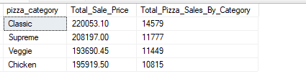

**Top 5 Best Sellers Pizza’s by Revenue, Quantity and Orders**

select TOP 5 pizza_name as Pizza_Name, sum(total_price) AS Total_Sale_Price, count(quantity) as Total_Quantity_Sold, COUNT(Distinct order_id) as Total_Orders_Sold from pizza_sales

group by pizza_name

Order by Total_Sale_Price Desc

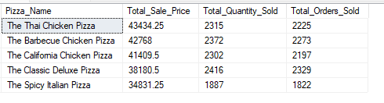

**Bottom 5 Worst Sellers Pizza’s by Revenue, Quantity and Orders**

select TOP 5 pizza_name as Pizza_Name, sum(total_price) AS Total_Sale_Price, count(quantity) as Total_Quantity_Sold, COUNT(Distinct order_id) as Total_Orders_Sold from pizza_sales

group by pizza_name

Order by Total_Sale_Price ASC

